CONTRAST

- Define Contrast:

- Describe how you get conflict. Is this good or bad?

- What did she do to Create Contrast in the 2nd Newsletter?

- What did they do to the Resume to make it better on the 2nd sample?

- On the 2nd mini poster what did they do to achieve contrast?

- What is the purpose of the bold text in the flyer below?
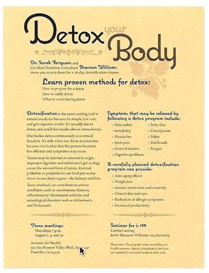

- Circle the Proximity in the groupings below in the flyer.

- Draw the strong alignments that you see in the sample of the flyer.

- In the layout below, which arrangement of information is stronger? Why? Describe what and how contrast has improved the design.

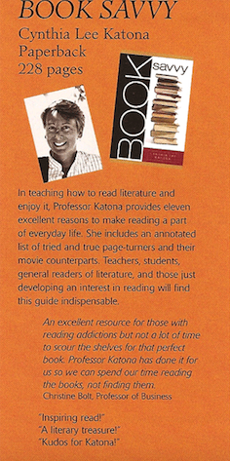
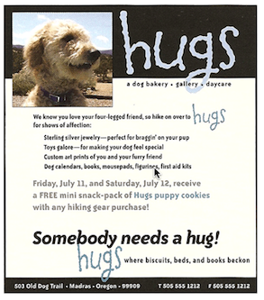
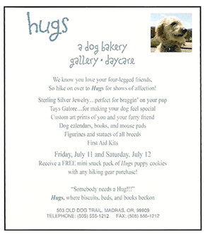
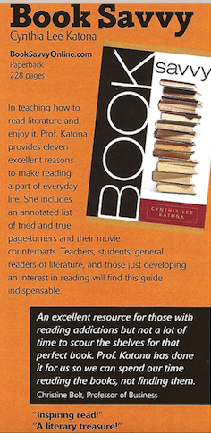
10. Looking Below, the ad to the right looks radically different then the one on the left. The four principles of design have been applied to the one on the right. Describe what they have done in each area to improve the layout below.
A. proximity

B. Alignment

C. Repetition

D. Contrast

B.
A.

