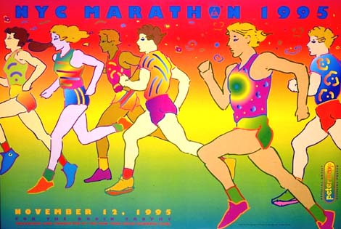
Peter Max Assignment

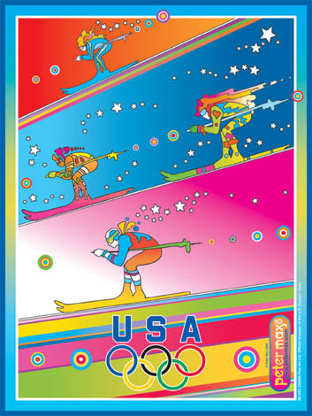
Background: Peter Max is a commercial artist. He has worked with paints, pastels, multi colored pencils, printmaking, animation cells, silk screens, and ceramics, sculpture, collage and computer graphics. He loves all media, including mass media and a canvas for his creative expression. He is well known for his stylized running or flying people with brightly colored prints and backgrounds. This project will be to transform a photo of people in action into a Peter Max style poster.

European born, Peter was raised in Shanghai, China, where he spent his first ten years. He lived in a pagoda-style house situated amidst a Buddhist monastery, a Sikh temple and a Viennese cafe.

Digital Technique: You will use the knowledge you gained from the Warhol project to help you with this one. You will need a digital picture of a group of people active in some sport. You will create patterns and use layers, filters to create a collage painting. Our goal in the end is to have a poster promoting exercise in different sports. Look at Olympic sports and try to imitate those sports in your pictures.

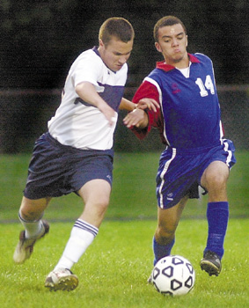
- Find an action sport picture on-line. Keep the background simple to erase later. It should be a large file. Keep the background simple to erase later. Save it into your file folder
- Open Adobe Photoshop program and browse for your image.
- 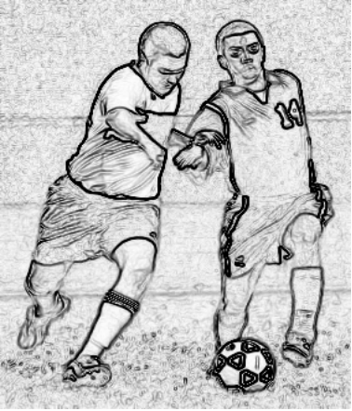Now turn your picture into a “coloring book page”
  - First get an outline by choosing
Filter- Stylize-Find Edges
  - Next remove the color by going
Image-Mode- Grayscale
  - Save as “coloringbook_your name”
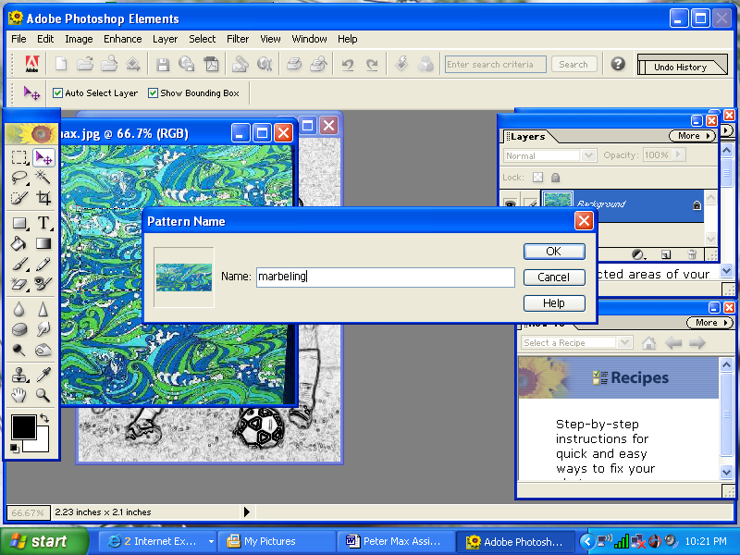
- Next you need to create patterns to use on your coloring book.
  - Find patterns off the internet and save in your documents folder. Think about your theme and think about what patterns look good together. Save at least 9 different patterns.
  - Open any of the pattern images, crop, adjust hues if you want. Now select just the best part of the pattern with the Rectangle Marquee tool.
  - To save go Edit-Define Pattern
  - Name your pattern in the pop-up box and hit OK.
  - Do this with all nine patterns you found.
  - Close all the pattern pictures.
4. Click back to your coloring book picture and then to Layer-New-Layer. Hit OK to create an invisible layer you will draw on.
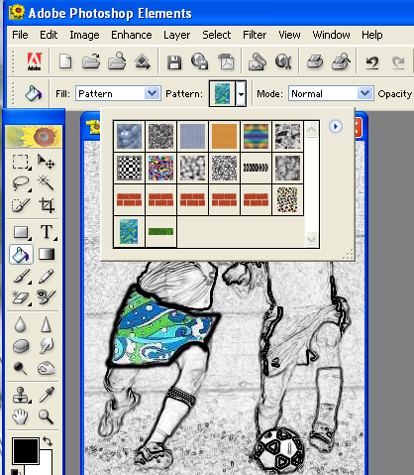
5. Get your Paint Brush from your side tool bar to draw lines on your “tracing paper OVER the darkened lines of your coloring book photo. Simplify and stylize your shapes as you trace.
6. Remember that each time you finish a task, you must click on your tool box to let it know your are done. Save Often so you don’t lose your progress.
7. You can wait until you have all your outlines drawn to fill your patterns or you can begin filling areas as you draw your outlines. To fill areas with a pattern get your Paint Bucket from your tool box. In your Bucket Selection menu at the top of the screen, change, Foreground to Pattern. Next you select which pattern you want to use by clicking the Pattern box. The pattern box should show you the names and a thumbnail of all the patterns you saved.
8. Continue drawing outlines with your Paint Brush and filling them with your Paint Bucket until you are done with the figures. You can use solid colors too. Form the paint box in addition to patterns. You will need to be in the Foreground setting for that.
9. When you are done drawing and filling your figures, go to your Layers window and throw away the coloring book layer, while keeping the layer with the outlines and patterns.
10. To complete the Peter Max style painting you will want to create a background using the Gradient Tool or the Paint Brush and Paint Bucket to create an interesting bold skyline. You can use the Shape Tool too for dynamic shapes in the background, like the examples above. You may need to erase background clutter first with the magic eraser or wand.
11. Finally add TEXT using the test tool in your tool box to give it a poster finish.
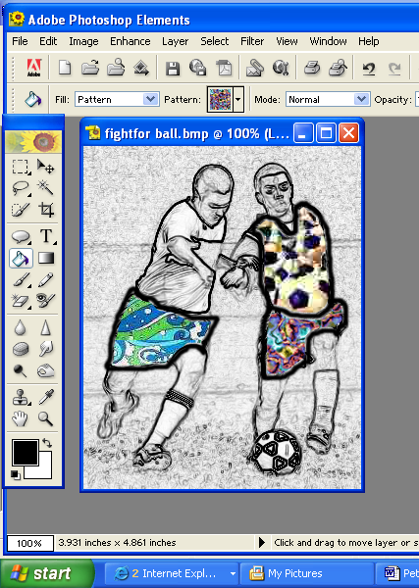
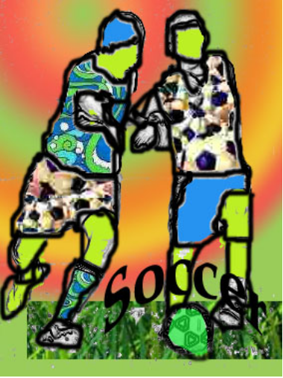12. When your are done, File-Save AS-JPEG, in the Format Drop box, name your assignment “your name_PeterMax”

